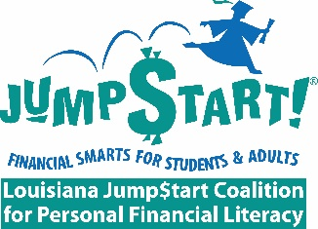

2019 Committee Selection Form

Name: ______________________________ Organization: ____________________________

Email: ______________________________ Phone: _________________________________

We ask our Louisiana Jump$tart members to help in promoting financial education in the schools, universities, workplace and with the low-income/unbanked population by volunteering to serve on one or more committees that fit well with your talents and interests.

Please check the committee(s) you would like to serve on in 2019. Return form by email to (info@louisianajumpstart.org ).

Thank You!

Standing Committees | Focus | √
Membership | Recruitment of new and potential members  Retention of current members
Marketing and Public Relations | Raise public awareness  Media relations  Member communications
Fundraising and Finance | Budget  Identify and manage grant or potential sponsorship opportunities  Annual audit
Ad Hoc Committees | Focus | √
Financial Literacy Month (April) | Media Coverage – TV shows, radio, and newspaper
Workplace Financial Education Program and Honor Roll | Promoting the need to provide financial education in the workplace and recognizing businesses and organizations who do
Delivering Financial Education Thru Multi-Media Channels | Creating education videos and webinars
Financial $marts for Students and Families | For high school students and family members
Train-the-Trainer Workshops | Sharing financial education programs with anyone who has a student or adult audience
Rev 12/02/16

